**Atul Anurag**

**PES2UG19CS075**

**COMPUTER NETWORKS LAB**

**Week #6**

**Designing and Simulation of Network Topology using Cisco Packet Tracer**

**Objectives:**

* To understand the purpose of Cisco Packet Tracer.
* To navigate, choose network and end devices and customize them.
* To interconnect devices and configure them using simple interface.
* To become familiar with building topologies in Packet Tracer.
* To simulate data interactions traveling through a network.

**Prerequisites:**

This lab assumes some understanding of the building blocks of communication networks and internet. At this point, we haven’t discussed other protocols but you may use Packet Tracer in later labs to discuss those as well. Several types of devices and network connections can be used. For this experiment we will keep it simple by using end devices, switches, routers, and connections.

**Task 1:**

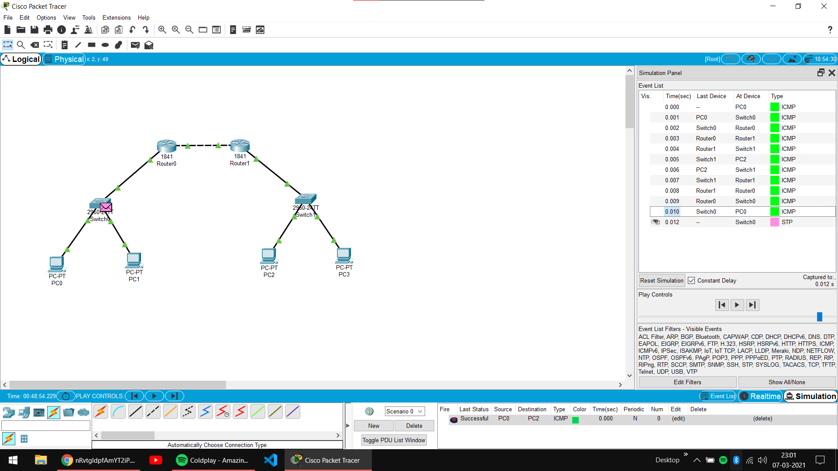

**PC & Router Configuration Details:**

**PC0:**

IP Address ---> 10.0.0.1

Gateway ---> 10.0.0.3

**PC1:**

IP Address ---> 10.0.0.2

Gateway ---> 10.0.0.3

**Router 0:**

FastEthernet0/0 ---> 10.0.0.3

FastEthernet0/1 ---> 20.0.0.1

**Router 1:**

FastEthernet0/0 ---> 20.0.0.2

FastEthernet0/1 ---> 30.0.0.1

**PC2:**

IP Address ---> 30.0.0.2

Gateway ---> 30.0.0.1

**PC3:**

IP Address ---> 30.0.0.3

Gateway ---> 30.0.0.1

**Routing Table Entries:**

**Router Network Next Hop**

Router 0 30.0.0.0 20.0.0.2

Router 1 10.0.0.0 20.0.0.1

**Task 2:**

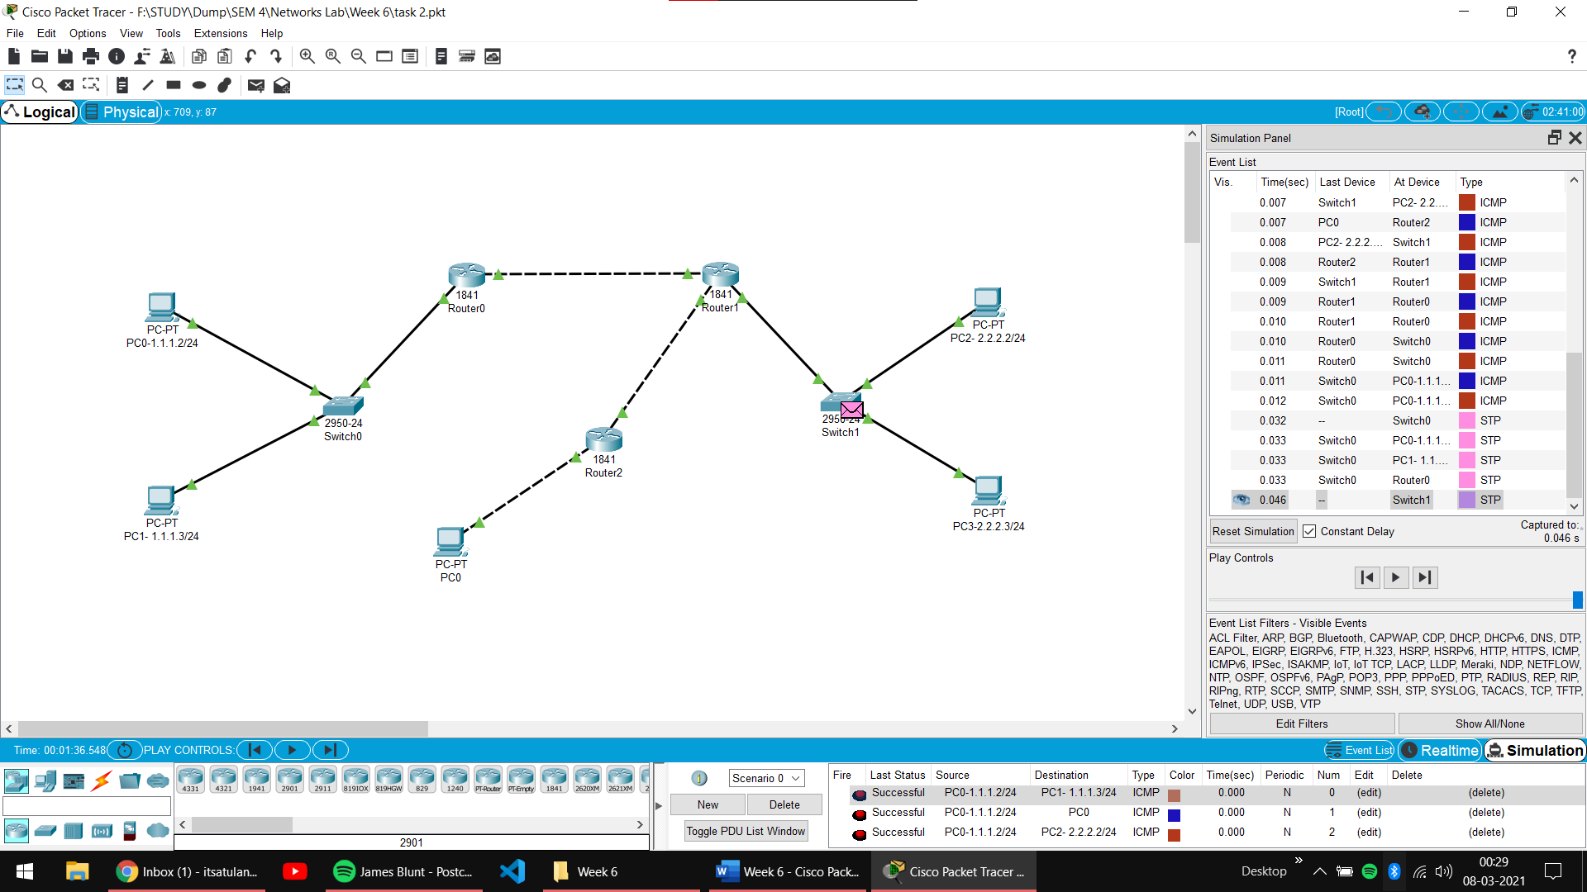

**PC & Router Configuration Details:**

**PC0-1.1.1.2/24 :**

IP Address 🡪 1.1.1.2

Gateway 🡪 1.1.1.1

**PC1-1.1.1.3/24 :**

IP Address 🡪 1.1.1.3

Gateway 🡪 1.1.1.1

**PC0 :**

IP Address 🡪 6.6.6.2

Gateway 🡪 6.6.6.1

**PC2-2.2.2.2/24 :**

IP Address 🡪 2.2.2.2

Gateway 🡪 2.2.2.1

**PC2-2.2.2.3/24 :**

IP Address 🡪 2.2.2.3

Gateway 🡪 2.2.2.1

**Router 0 :**

FastEthernet0/0 🡪 1.1.1.1

FastEthernet0/1 🡪 3.3.3.1

**Router 1 :**

FastEthernet0/0 🡪 3.3.3.2

FastEthernet0/1 🡪 5.5.5.2

Ethernet0/1/0 🡪 2.2.2.1

**Router 1 :**

FastEthernet0/0 🡪 5.5.5.1

FastEthernet0/1 🡪 6.6.6.1

**Subnet mask for all the devices** 🡪 **255.255.255.0 as the number of Network Bits is /24.**

**Routing Table Entries:**

|  |  |  |
| --- | --- | --- |
| Router | Network | Next Hop |
| Router 0 | 5.5.5.0/24 | 3.3.3.2 |
| 2.2.2.0/24 | 3.3.3.2 |
| 6.6.6.0/24 | 3.3.3.2 |
| Router 1 | 1.1.1.0/24 | 3.3.3.1 |
| 6.6.6.0/24 | 5.5.5.1 |
| Router 2 | 3.3.3.0/24 | 5.5.5.2 |
| 1.1.1.0/24 | 5.5.5.2 |
| 2.2.2.0/24 | 5.5.5.2 |